**CONFIDENTIAL  
  
  
CPS Readiness Report  
  
School: Dedham Schools MA  
  
Date Prepared: 10-18-2018**

**Table of Contents**

I. Background Information  
  
II. Quantitative Assessment  
  
III. Qualitative Assessment  
  
IV. CPS Readiness Summary  
  
V. Recommendations

I. Background Information

Implementation science has revealed that implementing any evidence-based approach requires changing the behavior of staff and the climate, culture, and structures of the organization. As a result, implementing with fidelity and sustainability requires time, patience, discomfort, perseverance, and good leadership.

The staff at your school completed surveys to provide us with quantitative information. Additionally, focus groups with your school's staff gave us additional qualitative information that we have used toward this final report. These focus groups facilitated our understanding of current practices and challenges that your staff face. Every organization has challenges; understanding exactly what yours are will help us know how and when to implement CPS to maximize its success.

After you review this report, the Think:Kids team will discuss recommendations with school leadership. In some cases, immediate CPS implementation is recommended, and if so, a proposed comprehensive implementation and evaluation plan, timeline, and associated costs will be discussed. In other cases, the Think:Kids team may recommend to leadership that particular readiness areas be addressed first, in order to maximize the benefits of implementation.

|  |  |
| --- | --- |
| **Key:** |  |
| Freq: | How many times a respondent responded in that way |
| Percent: | The percent of the entire sample who responded in that way |
| Cum: | Cumulative percent. The percent of that response and all that came in list before |
|  |  |
| Obs: | Number of respondents who completed this item or for whom the subscale could be calculated in a valid way |
| Mean: | Average of all relevant items |
| Std Dev: | Standard Deviation: Approximately 68% of responses fall within the mean plus or minus the standard deviation. For example, if the mean is 3 and standard deviation is 1, 68% of responses fall between 3+/-1, or between 2 and 4. |
|  |  |
| Min: | Minimum score for that item or category |
| Max: | Maximum score for that item or category |

II. Quantitative Assessment

**The CPS Adherence and Impact Measure (CPS-AIM)**

The CPS-AIM inquires about factors related to CPS. This pre-training measurement was taken so that we can monitor how staff’s adherence to the CPS philosophy increases over time. We also hope that over time we will see reduced burnout and perceptions of a more positive impact on youth.

**Survey Responders:**  
 65 total staff members responded to our CPS Adherence and Impact Measure Survey in a valid and reliable way. The quantitative analyses on the next few pages of this report are based on data collected from those respondents. The respondents are broken down by program, job role, and CPS training status as follows:

|  |  |  |  |
| --- | --- | --- | --- |
| **Staff Roles Educators** | Freq | Percent | Cum. |
| Classroom Teacher | 45 | 69.0% | 69.0% |
| Special Educator (including Literacy Specialist, etc.) | 7 | 11.0% | 80.0% |
| Other Educator | 4 | 6.0% | 86.0% |
| Paraprofessional/Classroom Aide | 4 | 6.0% | 92.0% |
| School Leadership/Administration | 3 | 5.0% | 97.0% |
| School-based Clinical Staff | 2 | 3.0% | 100.0% |

|  |  |  |  |
| --- | --- | --- | --- |
| **Staff Program** | Freq | Percent | Cum. |
| Dedham Middle School | 65 | 100.0% | 100.0% |

|  |  |  |  |
| --- | --- | --- | --- |
| **CPS Training** | Freq | Percent | Cum. |
| No Training | 36 | 55.0% | 55.0% |
| Not Sure | 22 | 34.0% | 89.0% |
| Recieved Training | 7 | 11.0% | 100.0% |

Scores range from 1=Strongly Disagree to 7=Strongly Agree. In the graph below, the horizontal line indicates a score of 4, which is “Not Sure.” The goal is to be far above the horizontal line in Adherence to CPS Philosophy and Perceptions of Positive Impact, and far below the horizontal line in Burnout.

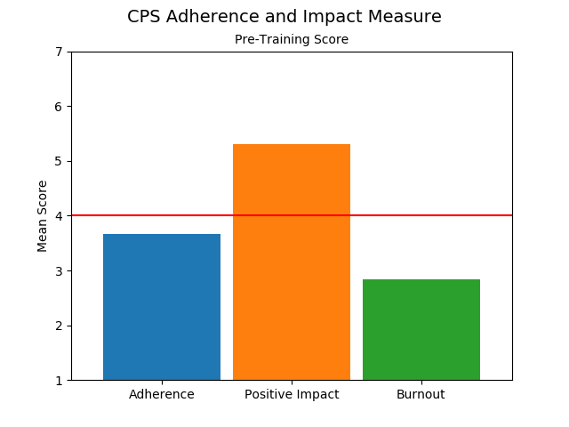

**Summary:** As a whole...

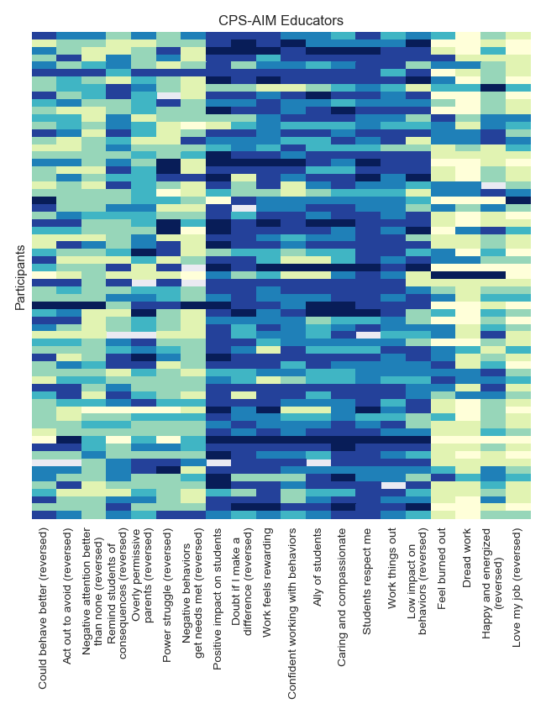

**The CPS Readiness Survey**

Evaluating readiness to implement an evidence-informed approach like CPS revolves around several factors. These include an agency’s *motivation for change, its general capacity* for implementation of any intervention, and its *specific capacity for implementation of the intervention in question* (in this case, CPS). These factors can vary by program or by role within the school.

Under the category of **Motivation for Change**, we assess whether the administrators/leaders as well as other staff see the need, and have enthusiasm for, a different or additional approach. **Capacity in General** refers to things such as whether staff feel appropriately supported and satisfied with their work, whether sufficient supervision, communication and documentation structures are in place, and whether there is strong leadership present to facilitate implementation. **Capacity for CPS** refers to a site’s ability to implement CPS in particular. For example, because CPS typically requires a significant shift in mindset, culture, and behavior from staff, it is even more important that influential culture-carriers be present. In addition, existing models of intervention must not directly conflict with the basic tenets of CPS that run counter to many conventional approaches aimed at motivating more compliant behavior externally through use of rewards and punishments.

To conduct a comprehensive readiness assessment across programs, we utilize a readiness survey designed explicitly for this purpose and based on the latest research on organizational readiness for implementation of an innovation (Scaccia et al., 2015).

**Survey Responders:**  
 68 total staff members responded to the CPS Readiness Surveys in a valid and reliable way. The quantitative analyses on the next few pages of this report are based on data collected from those respondents. The respondents are broken down by school, job role and years of employment as follows:

|  |  |  |  |
| --- | --- | --- | --- |
| **Staff Role** | Freq | Percent | Cum. |
| Classroom Teacher | 39 | 57.0% | 57.0% |
| Special Educator/Specialist | 11 | 16.0% | 74.0% |
| Classroom Aide/Paraprofessional | 9 | 13.0% | 87.0% |
| School-based Clinical Staff | 4 | 6.0% | 93.0% |
| Other Educator | 2 | 3.0% | 96.0% |
| Other | 2 | 3.0% | 99.0% |
| School Leadership/Administration | 1 | 1.0% | 100.0% |

|  |  |  |  |
| --- | --- | --- | --- |
| **Staff Program** | Freq | Percent | Cum. |
| Dedham Middle School | 68 | 100.0% | 100.0% |

|  |  |  |  |
| --- | --- | --- | --- |
| **Years at Organization** | Freq | Percent | Cum. |
| 11+ years | 30 | 44.0% | 44.0% |
| 6-10 years | 13 | 19.0% | 63.0% |
| 3-5 years | 10 | 15.0% | 78.0% |
| 0-1 years | 9 | 13.0% | 91.0% |
| 1-2 years | 6 | 9.0% | 100.0% |

**Readiness Survey Results, for All Employees**

Possible responses for readiness items range from 1 (Strongly Disagree) to 5 (Strongly Agree), with a 3 response for "Not Sure."

|  |  |  |  |  |  |
| --- | --- | --- | --- | --- | --- |
| Variable: | Obs | Mean | Std. Dev. | Min | Max |
| Motivation for Change | 68 | 3.9 | 0.52 | 1.83 | 4.83 |
| General Capacity | 68 | 3.7 | 0.77 | 1.8 | 5.0 |
| Capacity for CPS | 68 | 3.8 | 0.89 | 1.0 | 5.0 |

Summary: Overall, staff at Dedham Schools MA are…  
  
This spread can be seen in more detail below.

**Detail View: Motivation, General Capacity, and Capacity for CPS, for ALL STAFF**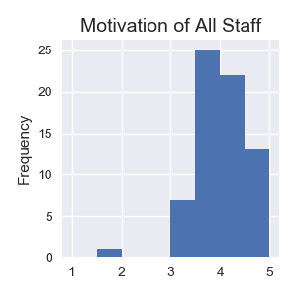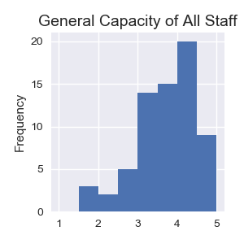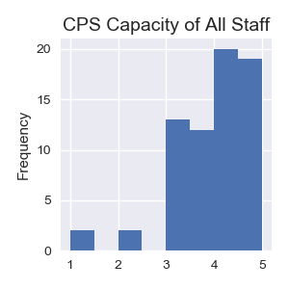

**Readiness Survey Results Staff**

|  |  |  |  |  |  |
| --- | --- | --- | --- | --- | --- |
| Variable: | Obs | Mean | Std. Dev. | Min | Max |
| Motivation for Change | 67 | 3.9 | 0.52 | 1.83 | 4.83 |
| General Capacity | 67 | 3.7 | 0.77 | 1.8 | 5.0 |
| Capacity for CPS | 67 | 3.8 | 0.88 | 1.0 | 5.0 |

**Readiness Survey Results Leadership/Administration**

|  |  |  |  |  |  |
| --- | --- | --- | --- | --- | --- |
| Variable: | Obs | Mean | Std. Dev. | Min | Max |
| Motivation for Change | 1 | 4.5 | nan | 4.5 | 4.5 |
| General Capacity | 1 | 2.8 | nan | 2.8 | 2.8 |
| Capacity for CPS | 1 | 5.0 | nan | 5.0 | 5.0 |

Summary: Across roles, staff at are…

**Detail View: Motivation, General Capacity, and Capacity for CPS, by Role:**

In order to preserve confidentiality, categories where there were less than 2 participants who answered the survey in their role were excluded from the following analyses.

Motivation by Role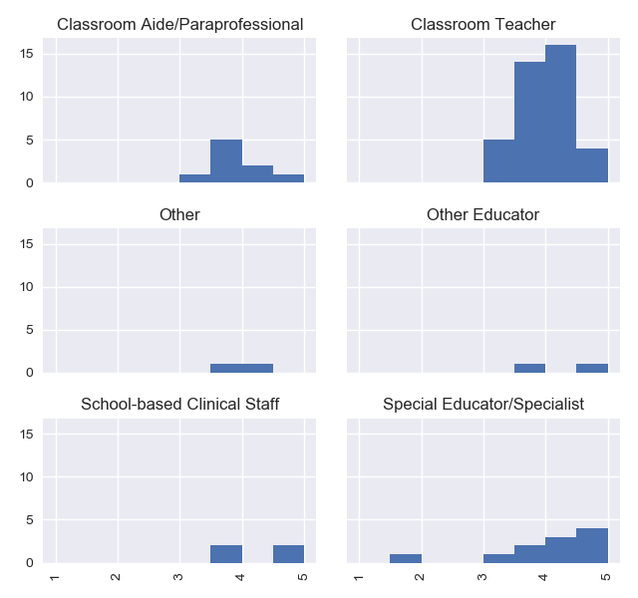

General Capacity by Role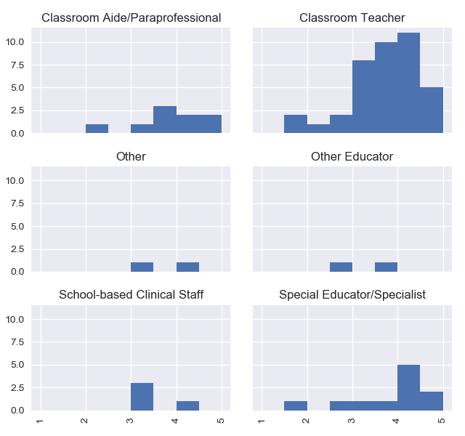

CPS Capacity by Role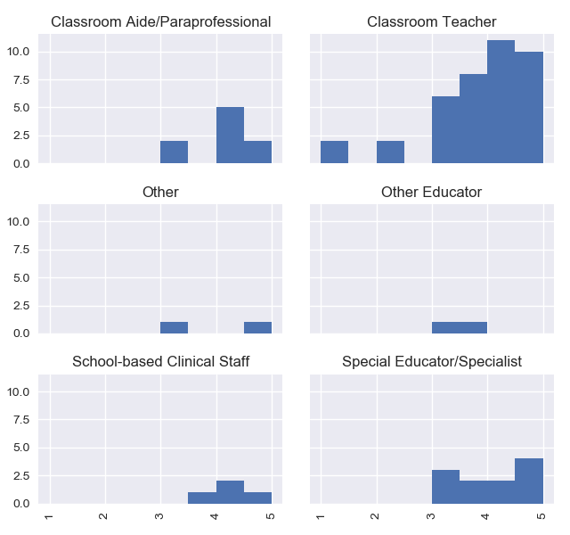

**Detailed Report of Educational Staffs’ Responses by Item:**

|  |  |  |  |  |  |
| --- | --- | --- | --- | --- | --- |
| Question: | Obs | Mean | Std. Dev. | Min | Max |
| **Motivation** |  |  |  |  |  |
| 1) Policies need improvement | 66 | 4.2 | 0.86 | 1.0 | 5.0 |
| 2) CPS is improvement | 65 | 4.0 | 0.84 | 2.0 | 5.0 |
| 5) CPS too hard (reversed) | 67 | 3.5 | 1.08 | 1.0 | 5.0 |
| 6) Leaders want all in | 67 | 4.3 | 0.85 | 1.0 | 5.0 |
| 7) CPS consistent with values | 66 | 4.2 | 1.0 | 1.0 | 5.0 |
| 8) CPS consistent with practice | 66 | 3.3 | 0.98 | 1.0 | 5.0 |
| **General Capacity** |  |  |  |  |  |
| 9) We encourage innovation | 67 | 3.9 | 0.96 | 1.0 | 5.0 |
| 10) Staff want to learn more | 67 | 3.8 | 1.04 | 1.0 | 5.0 |
| 11) Staff supported by leaders | 67 | 4.0 | 1.24 | 1.0 | 5.0 |
| 12) Staff communicate well | 67 | 3.6 | 1.23 | 1.0 | 5.0 |
| 13) Too many interventions (reversed) | 65 | 3.2 | 1.1 | 1.0 | 5.0 |
| **CPS Capacity** |  |  |  |  |  |
| 3) Leaders are committed | 67 | 4.3 | 1.01 | 1.0 | 5.0 |
| 4) Internal CPS team | 66 | 3.3 | 1.16 | 1.0 | 5.0 |

**\* Items have been truncated here to conserve space.  
See Appendix for item wording.**

**Detailed Report of Leadership/Administrators’ Responses by Item:**

|  |  |  |  |  |  |
| --- | --- | --- | --- | --- | --- |
| Question: | Obs | Mean | Std. Dev. | Min | Max |
| **Motivation** |  |  |  |  |  |
| 1) Policies need improvement | 1 | 5.0 | nan | 5.0 | 5.0 |
| 2) CPS is improvement | 1 | 5.0 | nan | 5.0 | 5.0 |
| 5) CPS too hard (reversed) | 1 | 5.0 | nan | 5.0 | 5.0 |
| 6) Leaders want all in | 1 | 5.0 | nan | 5.0 | 5.0 |
| 7) CPS consistent with values | 1 | 5.0 | nan | 5.0 | 5.0 |
| 8) CPS consistent with practice | 1 | 2.0 | nan | 2.0 | 2.0 |
| **General Capacity** |  |  |  |  |  |
| 9) We encourage innovation | 1 | 2.0 | nan | 2.0 | 2.0 |
| 10) Staff want to learn more | 1 | 2.0 | nan | 2.0 | 2.0 |
| 11) Staff supported by leaders | 1 | 3.0 | nan | 3.0 | 3.0 |
| 12) Staff communicate well | 1 | 2.0 | nan | 2.0 | 2.0 |
| 13) Too many interventions (reversed) | 1 | 5.0 | nan | 5.0 | 5.0 |
| **CPS Capacity** |  |  |  |  |  |
| 3) Leaders are committed | 1 | 5.0 | nan | 5.0 | 5.0 |
| 4) Internal CPS team | 1 | 5.0 | nan | 5.0 | 5.0 |
| 14) Financially committed | 1 | 5.0 | nan | 5.0 | 5.0 |

**\* Items have been truncated here to conserve space.  
See Appendix for item wording.**

III. Qualitative Assessment

**Summary of Need:**  
 **Readiness strengths:**  
 **Readiness areas in need of improvement:**

Readiness Area: Motivation for Change

Readiness Area: Capacity in General

Readiness Area: Specific Capacity for CPS

**Heat Maps**

The following is a graphical representation of each readiness survey item (columns) rated by each respondent (rows). Items have been truncated to save space; see the appendix for original item wording. Possible responses range from 1 (Strongly Disagree) to 5 (Strongly Agree), with a 3 for "Not Sure." Scores have been reversed when necessary so that higher scores and darker colors always indicate better readiness. Thus, columns with a lot of beige or light green indicate readiness areas in need of improvement.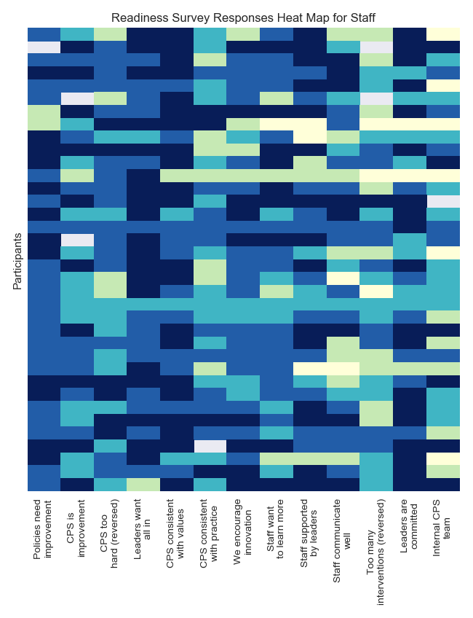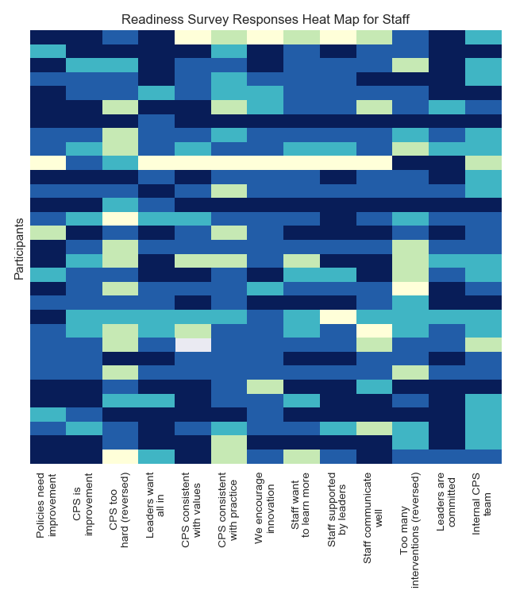

IV. CPS Readiness Summary

**Summary of Need:**  
  
Dedham Schools MA is...  
On the whole, Dedham Schools MA staff...

**Readiness Strengths and Areas for Improvement**  
Based on the quantitative results of the readiness assessment, Dedham Schools MA appears to be <options: very well positioned, well positioned, not yet ready> to implement CPS. *Readiness strengths:*

Readiness area for improvement:

|  |  |  |
| --- | --- | --- |
|  | Score: 0=Not at all 1=Partially 2=Definitely |  |
| **Motivation for the Innovation*:** | **Perceived incentives and disincentives that contribute to the desirability to use CPS** | **AVG:** |
| Relative advantage | Is CPS perceived as being better than what it is being compared against or what already exists (including perceptions of anticipated outcomes)? Is there a desire to change if the organization has a motivation-based system? Is there staff buy-in at all levels? | - |
| Compatibility | Is CPS perceived to be consistent with existing values, cultural norms, experiences, and needs of potential users? If other treatment models are being implemented within the organization, is implementation consistent with the CPS philosophy? Is there an organization-wide stance on critical incidents that is consistent with CPS (e.g., a priority to reduce coercive and physical intervention)? | - |
| Complexity | Is CPS perceived as being of reasonable complexity to understand and use? | - |
| Trialability | Can CPS be tested and experimented on within this organization? Does the organization feel they can try it out or pilot it in a small group? | - |
| Observability | Will outcomes that result from CPS be visible to others? Will there be observable short term gains or "small wins?" | - |
| Priority | Is CPS mandated/required or will it likely solve a problem that the organization must solve? | - |
|  |  |  |
| **General Capacity:** | **Factors that contribute to the ability of the organization to implement any innovation** | **AVG:** |
| Culture | Is the overall culture one that feels open to innovation? | - |
| Climate | How do employees collectively perceive, appraise, and feel about their current working environment? Does the organization have a low burnout rate, do they feel adequately staffed and supported by leadership? | - |
| Organizational innovativeness | Are the staff generally receptive toward change? Are staff feeling overwhelmed by multiple initiatives and EBPs? Are staff engaged in regular professional development opportunities? | - |
| Resource utilization | Are there fiscal resources to put to training and coaching over the longer term, to ensure sustainability? Does the budget contain allocated funding for implementation of a new intervention or is there other evidence of a plan for ongoing financial support? | - |
| Leadership | Do organizational leaders articulate and support organizational activities? Do leadership staff have the time and energy needed to devote to a new intervention? | - |
| Structure | Does the organization have good processes for good organizational functioning on a day-to-day basis? Does the organization have clear and organized documentation practices, good communication between staff and shifts, and good supervisory structures? | - |
| Staff capacity | Do the staff possess the appropriate skills, education, and expertise to be able to engage with an innovation? | - |
|  |  |  |
| **CPS-Specific Capacity:** | **The human, technical, and fiscal conditions that are important for successfully implementing this particular innovation with quality** | **AVG:** |
| CPS-speciﬁc knowledge, skills, and abilities | Do staff have the knowledge, skills, and abilities needed for CPS in particular, or will they be likely to gain these? | - |
| Program champion | Is there a CPS champion (Individual who will put charismatic support behind CPS through connections, expertise, and social inﬂuence)? Are there individuals that can comprise a core team of internal CPS coaches or CPS team leaders providing regular support within the organization? | - |
| Speciﬁc implementation supports | Is there a presence of strong, convincing, informed, and demonstrable support for CPS at the leadership level? Does the organization have the policies, software, or hardware necessary to get CPS off the ground? | - |
| Available time | Can direct care hours be adjusted to allow for ongoing coaching in CPS? Are staff going to have adequate time to formally learn about CPS? | - |
| Finance | If reimbursement for services is needed, are current reimbursement mechanisms able to cover CPS? | - |
| Interorganizational relationships | Are there relationships between (a) providers and support systems and (b) different provider organizations that can be used to facilitate implementation (e.g., referral sources, etc)? | - |
| Informing stakeholders | Will the organization be able to answer specific stakeholders' questions about CPS (e.g., through development of materials)? | - |
|  |  |  |
| - | Total Readiness (R=M*C*C; range 0 to 8) | - |

V. Recommendations

Based upon the complete results of this readiness assessment, our Readiness Team feels that Dedham Schools MA is in excellent shape to continue to the next phase of implementation. Our recommendations are as follows:

Prior to Training

Training and Coaching

Moving Toward Sustainability

Appendix

**Organization-Wide Implementation Readiness Survey**

FOR STAFF:

1) Our school-wide discipline systems need to be changed/improved. (Motivation for Change)

2) I consider Collaborative Problem Solving (CPS) to be an improvement over what we are currently doing. (Motivation for Change)

3) Our school leaders are committed to providing the time and resources necessary to help us implement CPS. (CPS Capacity)

4) I would be interested in participating on a school-wide team to help guide and troubleshoot the implementation of CPS. (CPS Capacity)

5) CPS seems like it may be too complicated and time-consuming for me to be able to use effectively. (Motivation for Change) (Reversed)

6) It is clear to me that the leadership expects us all to implement CPS. (Motivation for Change)

7) CPS is consistent with my current values, goals, and needs as an educator. (Motivation for Change)

8) CPS is consistent with other behavioral practices we are currently using. (Motivation for Change)

9) Our school is one that encourages and supports new, innovative approaches. (General Capacity)

10) I have the interest and time to expand my knowledge and learn new programs. (General Capacity)

11) I feel supported by school leadership. (General Capacity)

12) Staff usually communicate openly and honestly at our school. (General Capacity)

13) We currently have too many new initiatives going to be able to start a new one. (General Capacity) (Reversed)

FOR LEADERS/ADMINISTRATION:

1) Our school-wide discipline systems need to be changed/improved. (Motivation for Change)

2) I consider Collaborative Problem Solving (CPS) to be an improvement over what we are currently doing. (Motivation for Change)

3) I am committed to providing the time and resources necessary to help us implement CPS, including revisiting our disciplinary plans and policies. (CPS Capacity)

4) I will have the staff and resources necessary to set up a school-wide team to help guide and troubleshoot the implementation of CPS. (CPS Capacity)

5) CPS may be too complicated and time-consuming for the staff to be able to use effectively. (Motivation for Change) (Reversed)

6) I will expect all staff (educators, clinical, and administrative staff) to implement CPS. (Motivation for Change)

7) CPS is consistent with the current values, goals, and needs of this school. (Motivation for Change)

8) CPS is consistent with other behavioral practices we are currently using. (Motivation for Change)

9) The staff at this school are generally open to trying new, innovative approaches. (General Capacity)

10) Our school is one that values expanding the knowledge and abilities of its staff. (General Capacity)

11) The school staff generally feel supported and valued by leadership. (General Capacity)

12) Staff communicate openly and honestly at our school. (General Capacity)

13) We currently have too many new initiatives going to be able to start a new one. (General Capacity) (Reversed)

14) I am committed to dedicating the necessary financial resources to implement CPS in a way that ensures long-term sustainability, including training, coaching, evaluation, and developing an internal team of CPS trainers. (General Capacity)